**BRICS STI Framework Programme  
Coordinated call for BRICS multilateral projects – 2nd Call 2017**

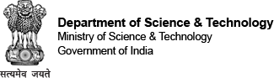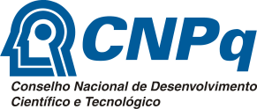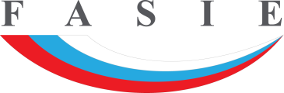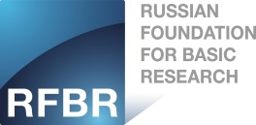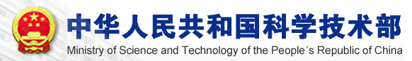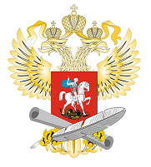

1. Thematic area (tick the box)

|  |  |
| --- | --- |
| Prevention and monitoring of natural disasters | Water resources and pollution treatment |
| Material science including nanotechnology | New and renewable energy, and energy efficiency |
| Information technologies and high performance computing | Biotechnology and biomedicine including human health and neuroscience |

2. Title of Cooperative Research Project

|  |
| --- |
| Full title: |
| Acronym: |

3. Abstract

|  |  |  |  |
| --- | --- | --- | --- |
| Keywords |  |  |  |
|  |  |  |
| Abstract (main contents of research including different roles to be played by each research team) |  | | |

4. Proposed Period of Cooperative Research Project

|  |  |
| --- | --- |
| 2 years | 3 years |

5. Research Teams

The research team of the “Lead PI (coordinator)” should be indicated as the “1st country” (if 4th or 5th country joints, please create additional table).

(1st country name) Researchers in Research Team

|  |  |  |  |  |
| --- | --- | --- | --- | --- |
| Name | Organization, Division | Title | Degree | Speciality |
| (Leader) |  |  |  |  |
|  |  |  |  |  |
| (Researchers) |  |  |  |  |
|  |  |  |  |  |
|  |  |  |  |  |
|  |  |  |  |  |
|  |  |  |  |  |
|  |  |  |  |  |

(2nd country name) Researchers in Research Team

|  |  |  |  |  |
| --- | --- | --- | --- | --- |
| Name | Organization, Division | Title | Degree | Speciality |
| (Leader) |  |  |  |  |
|  |  |  |  |  |
| (Researchers) |  |  |  |  |
|  |  |  |  |  |
|  |  |  |  |  |
|  |  |  |  |  |
|  |  |  |  |  |
|  |  |  |  |  |

(3rd country name) Researchers in Research Team

|  |  |  |  |  |
| --- | --- | --- | --- | --- |
| Name | Organization, Division | Title | Degree | Speciality |
| (Leader) |  |  |  |  |
|  |  |  |  |  |
| (Researchers) |  |  |  |  |
|  |  |  |  |  |
|  |  |  |  |  |
|  |  |  |  |  |
|  |  |  |  |  |
|  |  |  |  |  |

# 6. Budget plan

(Please write down only “Requested budget” and consult with your own country’s funding organization regarding eligible expenses since rules differ from country to country. See also national annexes for additional information (if 4th or 5th country joints, please create additional lines in a table below)

|  |  |  |  |
| --- | --- | --- | --- |
|  | Total funding in local currency for the 1st year | Total funding in local currency for the full duration of the project | National funding organization to request funds from |
| (1st country name) |  |  | Выберите элемент. |
| (2nd country name) |  |  | Выберите элемент. |
| (3rd country name) |  |  | Выберите элемент. |